Power generator in the nonlinear inductance

Designed and built device with efficiency greater than 1. Works in a self-sustaining mode, thus highlighting the tremendous amount of energy it takes to glow lamps. .......
At time t1:
The current from the pre-charged capacitor C1 flows through L1 - L2 - L3, while the switch S1 is closed. In this case, S2 open: On since the L1 and L2 are included in opposite (Accumulation of energy in the L1 and L2 does not occur, since their magnetic fields cancel each other) that the energy accumulation occurs in the coil L3 At time t2: Switch S1 opens and closes the key S2. Thus there EMF in the coils L1 and L3 (For since S2 is closed) Coils L1 and L3 is now operating in-phase (antiphase in turn EMF deducted and common-folded)
Since the current in the coils of the same, we are deemed to be received EMF at time t2 twice bolsheypo expended in relation to the accumulation energy at the moment t1. As used herein, represents one cycle of the coil. The control circuit provides a repetition of the process described above. The feedback loop returns a portion of the input received power circuits, for regular cycles.
The resulting increase in power consumed R - load.
1
So here! I once drank a beer, and the idea came to me!
Well, guys! Stagnant Slavic idea, full of chatter went in search of money and bodily pleasures! Let us let's get serious reengineering tasks proposed by Valery. I must say that the information he put a lot of spervonachalu although you could not tell. To begin with, suppose that the device actually exists and works. The theory is described in sufficient clarity and may truthfully. It is possible that some important points are de-emphasized. To further correct understanding-I would like that sometimes you have carefully read the original description of the device and carefully considered the proposed author photo.
So let's start!
The first thing we want to look at is the fact that the device is clearly applied KA34063 chip. This chip incorporates a reference voltage, the comparator compares the reference voltage with the output (via splitter) controls the output of the internal oscillator to the amplifier switch (1.5 A) mikroshemku very typical for a single-cycle flaybeka and the theory described by the author is included under the scheme Step-UP where Ui.> = Vout. The most interesting thing is that it is a base unit. It is obvious from the fact that inherently cannot be used without the presence of inductance. And judging by the photos, there is only one inductor as trifilyarnoy pot-core coils. So we can assume that in the form of a key S1 we have is this chip that is KA34063 (TS34063) For normal operation of the chip in a harness must be present:
a) inductance - L1 + L2 + L3 + diode + + electrolyte RLoad
b) Ct-510pf capacitor is a timing
c) Goshkoobrazny core OB30 M1500 -3 winding (50 turns of PEL inductance 0.35 - 3 x 716 uH) on a two-section (standard for this type of cores) coil. In one section bifilyar L1 and L2, in other L3.Nu and natural air zazorchik to 0.5mm (both in theory it should be).
g) plus the rest of the junk (look AN920 http://onsemi.com mikruhi for use in the internet)

Well, that's kind of scheme is starting to take its face. So what about KA34063 nobody has anything against? And she arose as S1 (the author) is quite beautiful. Now further. We need key S2! Well, let's stick a vtupuyu polevichok on the author's theory. Where we did not disappear!
Well, I turned up polevichki 2N7000 500 mA so I threw in a couple of them (another channel and volume resistivity is twice reduced from 5 to 2.5 ohm)
The scheme is self-sufficient and the like on the theory should work. But it is unlikely, though, if only because in the photo we see another mikruhu by 14 feet plus piping as trim resistor, capacitor (this is a timing chain) well and rest a little junk in the form of resistors. Prior to that, I think it’s time to get there.
Well ... of course included, of course does not work as it would be desirable! Points A and B are naturally on the two rays C1-99.
Picture is somewhat unusual. The frequency of about 2 kHz. The duty cycle of about 5, which does not correspond to the author. Porosity must be 2 and the frequency of about 100 kHz.
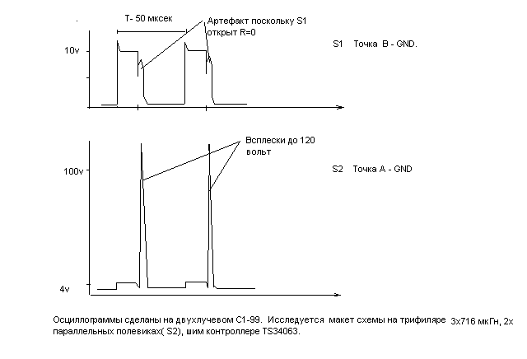
So, clearly shows that this spike appears after the closing of S2 at the wrong time, ie while the public key of S1. At this time, L3 is already saturated current key and this surge in the L2 only useless oversaturate L3. By the way this pulse energy is clearly not frail
There is a desire to count the culprit Seoul and move forward in time that is shorten by half the opening key S2. As a result, it is expected that the surge will appear in the second half of the time the private key S1 and was supposed to be put through the diode on the buffer capacitor and of course the load. How so? After going through all the available memory in these elements I have come to the conclusion that this is a common chip called 155AG1. It is best suited for this purpose. Actually, she has 14 legs. Here are just a food puncture. Need only some 5 volts. Do not worry, we add in a low-power circuit Three-terminal regulator parametric 78L05 (100 mA is enough), plus elektrolitik 100mkfh10volt. Well, in order to e155AG1 not knocked on input 5 (start rising edge, input 3 on the ground) high voltage put restrictive divider resistors and 750th stabilitronchika KS147 than limit the amplitude of the trigger pulse. Now on to the leg of 9 halts trimmer on 47 com and on the legs 10 and 11 to 510 pF capacitor. Now, where have bungled the management polevichkom S2 (I have their parallels of the two sticks and one with Valeria, medium size, on the left side of the board!).
So for this purpose, that would not burn out 155AG1 put regular pnp tranzistorchik, well, for example through the BS557 and 100 ohm resistor in the base Sui him out with six legs, the emitter, of course, to the gate resistor polevichka and 1 set to tie up his overall nutrition. Here in this form and he must open and close! Now, if you carefully read all of the photograph Valerina device until you see the piece all of these components. The scheme becomes more logical view. Everything else will approach more correctly and rewind reel to lower inductance. If you see an example of the calculation in the document AN920 (http://onsemi.com) is the inductance of the scheme should be Figure18 115 mN. This inductance and if I get wound 20 turns of PEL 0.35. So we 3h115 mN (L1, L2L3)
Well, you only heat the soldering iron and solder!

